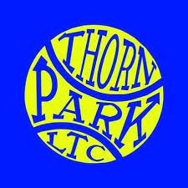

Thorn Park LTC Policy on Unsupervised Children

We recommend that children under the age of 12 are supervised by their parents/carer whilst at this tennis venue and outside of any official sessions, such as coaching lessons, tennis camps or match practice sessions.

Children under the agreed age of supervision should never be left unsupervised by a parent/carer even if there are other adults or coaching staff present. If the parent/carer is unable to supervise their child, arrangements need to be made by the parent/carer to designate an alternative adult to supervise. The venue/coaching staff and child must be aware of any such arrangements.

Arriving and leaving the venue alone:
Children under the age of 12 should not be allowed to arrive at or leave the venue alone unless the coaching team have written consent from the parent/carer.

